Design Notes

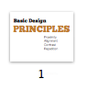

Introduce the 4 principles!

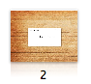

Along the way, we’ll be redesigning this business card.

Proximity

Items relating to each other should be grouped close together. When several items are in close proximity to each other, they become one visual unit rather than several separate units. This helps organize information, reduces clutter, and gives the reader a clear structure.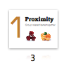

When several items are in close proximity to each other, they become one visual unit rather than several separate units.

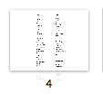

List:

You understand the principle of proximity instantly. And you understand it without even being conscious of it. You know these sections are somehow different because they are physically separated from the rest.

I’m sure you already do this automatically—I’m just suggesting that you now do it consciously and thus with more strength.

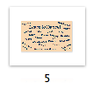

Learn to Dance:

The designer’s intention with this dance postcard was probably to create something fun and energetic, but at first glance, can you tell when and where the classes are happening?

In the redesign, by using the principle of proximity to organize the information (as shown below), we can communicate immediately who, what, when, and where.

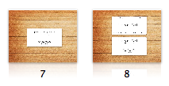

Business Card:

Where do you begin reading? In the middle, probably, because that phrase is boldest.

What do you read next—left to right (because it’s in English)?

What happens when you get to the bottom-right corner, where does your eye go?

Do you wander around making sure you didn’t miss any corners?

In this redesign, you know where to look, in what order, and what's most important.

Proximity review:

Physical closeness implies a relationship, separation implies a difference. So if two things are not not related, move them apart from each other!!

Simply grouping related elements together into closer proximity automatically creates organization, and if the information is organized, it is more likely to be read and more likely to be remembered. Don’t stick things in the corners or in the middle just because the space is empty.

Alignment

Nothing should be placed on the page arbitrarily. Every element should have some visual connection with another element on the page. Even when aligned elements are physically separated from each other, there is an invisible line that connects them, both in your eye and in your mind

Left: mostly webages

Right: magazines:

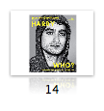

Left & Right:

￼Occasionally you can get away with using both flush right and flush left text on the same page, but make sure you align them in some way

Justified: Ebooks and Newspapers.

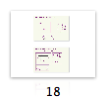

Chart:

What connects to what? Is that an annotation or a caption? It looks messy. By simply lining up the elements, it looks clear and clean.

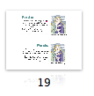

Photo:

If you have a photo or a graphic with a strong flush side, align the side of the text along the straight edge of the photo,

Centered:

A centered alignment is the most common alignment that beginners use—it’s very safe, it feels comfortable. A centered alignment creates a more formal look, a more sedate look, a more ordinary and oftentimes downright dull look.

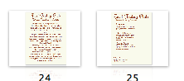

Winter Schedule:

Pretty boring (nothing pulls your eyes in to the body copy to take a look), and difficult to find the information…

What is going on, where is it happening, what time is it at, etc.

In the redesign, we have changed some sizes of text and alignment, principles we'll get too, but it is much clearer because elements that are intellectually connected, those that have some sort of relationship, are also visually connected

Exercise:

Check every element to make sure it has a visual connection to something else on the page. Check for illustrations that hang out over the edge just a bit, or captions that are centered under photos, headlines that are not aligned with the text, rules (lines) that don’t align with anything, or a combination of centered text and flush left text.

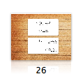

Business Card: Items just thrown on, no connection. By aligning on the right, instantly a much strong line, and a common boundary that connects them.

Alignment review:

Be conscious of where you place elements. Always find something else on the page to align with, even if the two objects are physically far away from each other. Avoid using more than one text alignment on the page (that is, don’t center some text and right-align other text). And please don't center unless you must!

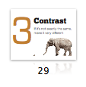Contrast

The idea behind contrast is to avoid elements on the page that are merely similar. If the elements (type, color, size, line thickness, shape, space, etc.) are not the same, then make them very different. Contrast is often the most important visual attraction on a page—it’s what makes a reader look at the page in the first place.

. The important rule to remember is that for contrast to be effective, it must be strong. Don’t be a wimp. “If two items are not exactly the same, then make them different. Really different.”

You can contrast large type with small type; a graceful oldstyle font with a bold sans serif font; a thin line with a thick line; a cool color with a warm color; a smooth texture with a rough texture; a horizontal element (such as a long line of text) with a vertical element (such as a tall, narrow column of text); widely spaced lines with closely packed lines; a small graphic with a large graphic.

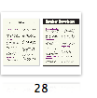

Newsletter.

Nothing really attracts the eyes to it. If no one’s eyes are attracted to a piece, no one will read it. But with a stronger, bolder typeface in the headlines and subheads, larger and bolder type size, headlines are so strong now, I could add a dark band across the top behind the title, again repeating the dark color and reinforcing the contrast.

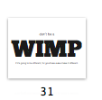

Don’t be a wimp!!!

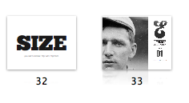

Use size to your advantage, here’s an online mag that makes great use of these typographic marks and letterforms –– BIG!

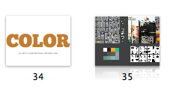

Also use color to highlight important info. Pick colors that are different! Get serious.

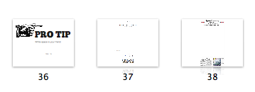And don’t be afraid of white space, it can also be used as a contrast, to draw the eye to the important info, or to make a point. White space is also contrast! Don’t feel the need to fill in all the edges.

Contrast review: Contrast on a page draws our eyes to it; our eyes like contrast. If you are putting two elements on the page that are not the same (such as two typefaces or two line widths), they cannot be similar—for contrast to be effective, the two elements must be very different.

Repetition

Repeat visual elements of the design throughout the piece. You can repeat colors, shapes, textures, spatial relation- ships, line thicknesses, fonts, sizes, graphic concepts, etc. This develops the organization and strengthens the unity.

Repetition can be thought of as “consistency.” But repetition goes beyond just being naturally consistent—it is a conscious effort to unify all parts of a design.

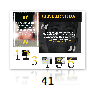Here the same typeface, color, dotted line, effects are used throughout to emphasize a common look and feel.

You already use repetition in your work. When you make headlines all the same size and weight, when you add a rule a half-inch from the bottom of each page, when you use the same bullet in each list throughout the project—these are all examples of repetition. Headlines and subheads are a good place to start when you need to create repetitive elements, since you are probably consistent with them anyway.

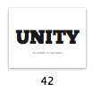Repeating elements can help internally organize and unify a piece  
  
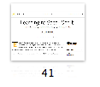Here, using the same color throughout helps establish this article’s look and feel.  
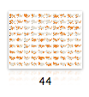In information graphics, repetition can be used to indicate that these things are the same (orange indicates drought), and compare differences.  
  
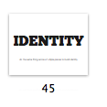

When you have multiple pieces, you need to indicate somehow that they belong together. Here are other examples of repetition used across an entire aritcle page or across multiple products to create a look and feel for that brand or particular online experience.

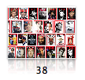TIME magazine repeats its logo on all magazines, does a great job at being consistent and establishin an identity.   
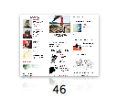The New Yorker uses the same characteristic typeface across its site to instantly convey that you are reading the New Yorker.   
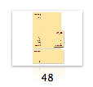If you are designing different products ( a business card and stationary, or a website and video series, etc)  Pick a color, typeface, or other graphic element to repeat.

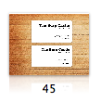

Business Card:

Now when you get to the end of the information, where does your eye go? Do you find that it bounces back and forth between the bold type elements? It probably does, and that’s the point of repetition—it ties a piece together, it provides unity.

Repetition review: A repetition of visual elements throughout the design unifies and strengthens a piece by tying together otherwise separate parts. Repetition is very useful on one-page pieces, and is critical in multi-page documents (where we often just call it being consistent).

Overview: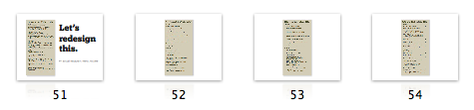

Gertrudes Piano Bar Menu

1. This is an actual restaurant menu. Really. The biggest problem, of course, is that all the information is one big chunk.

Before trying to design with this information, write out the separate pieces of information that belong together; group the elements. Don't think too much about it.

2. I put more space between the separate menu items. Of course, one should almost never use all caps because they are so hard to read, so I changed it to caps and lowercase. And I made the type a couple of point sizes smaller, both of which gave me a lot more room to work with so I could put more space between the elements.

It’s okay to set the type smaller than 12 point! Really!

3.Separate the “Starters” and the “Entrees.” Let’s indent each section— watch how the extra space defines these two groups even further, yet clearly communicates that they are still similar groups. Also enlarged the size of “Starters” and “Entrees” also, (Contrast)

4.  Type: chose a more interesting typeface than Times New Roman— that’s easy to do. Indent the descriptions of the menu items, which helped to clarify each item a little further.

It bothered me that the prices of the items were tucked into the text (with dorky hyphens), so I aligned them all out on the right where they are easily visible and consistently arranged. (Alignment)

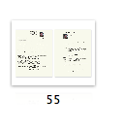

Resume:

There are two alignments on the page: centered and flush left.

The amounts of space between the separate segments are too similar.

The setup is inconsistent—sometimes the dates are on the left, sometimes on the right. Remember, consistency creates repetition.

The job titles blend in with the body text.

Resume Redesign:

One alignment: Flush left. As you can see above, using only one alignment doesn’t mean everything is aligned along the same edge—it simply means everything is using the same alignment (all flush left or all flush right or all centered). Both the flush left lines above are very strong and reinforce each other (alignment and repetition).

The heads are strong—you instantly know what this document is and what the key points are (contrast).

Segments are separated by more space than are the individual lines of text (contrast of spatial relationships; proximity).

Degree and job titles are in bold (a repetition of the headline font)—the strong contrast lets you skim the important points.

\*